IT24102724

PS LAB 05

1)

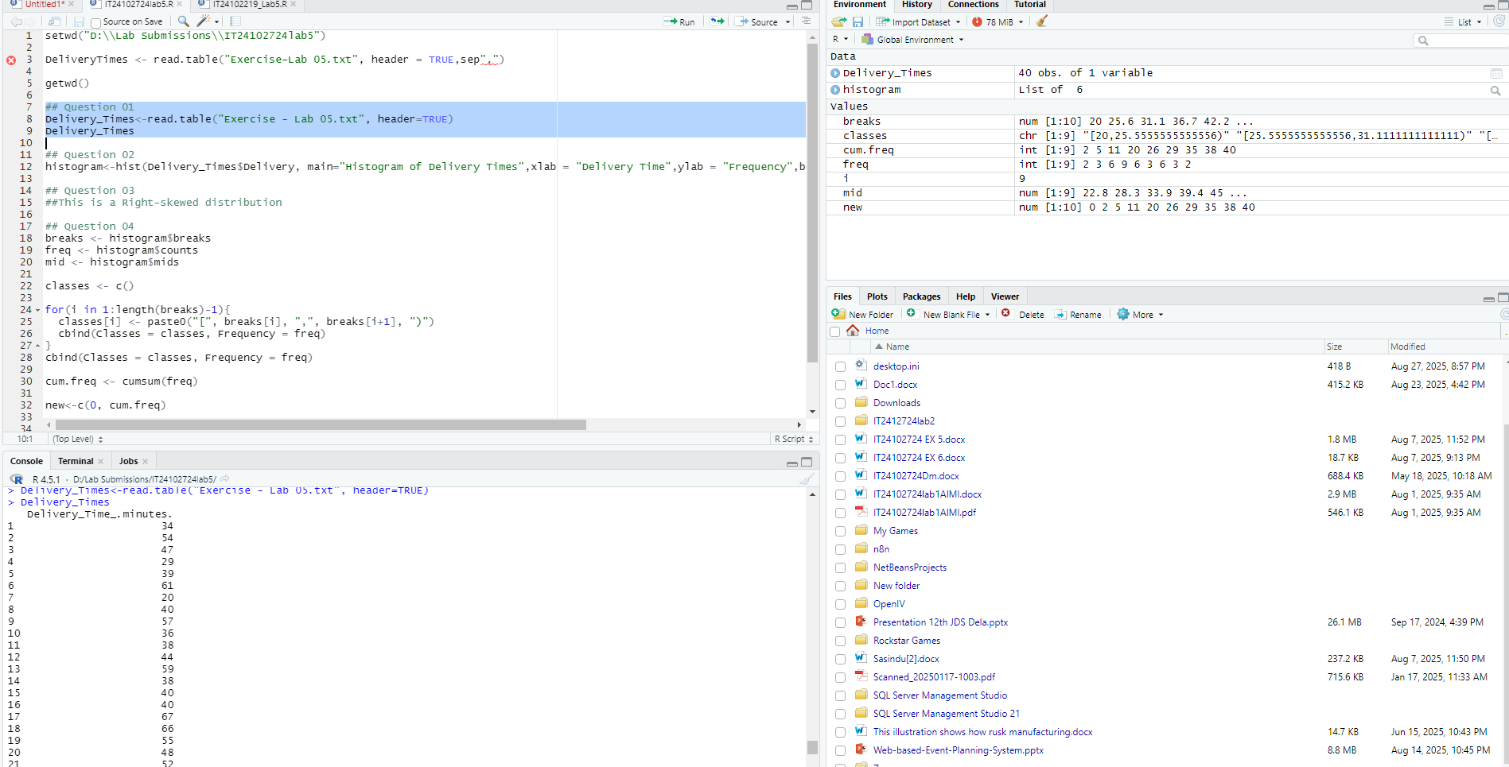

2)

4)



